 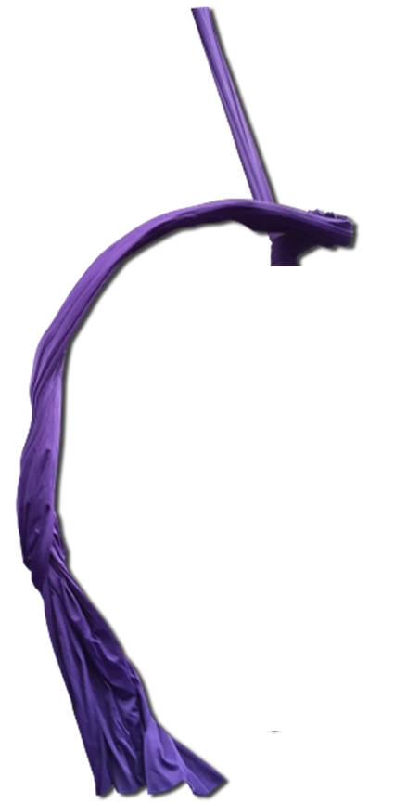

**Month: Lab Monkey:**

Lin Lab - 2018

Buffers & Waste Duty!!!

**I came in like a wrEHHHcking ball!**



December Nathan

September Mark

October Mike

November John

August Nathan

July Ben

June Qi

May Yang

March John

April Zhao

February Mike

January NA