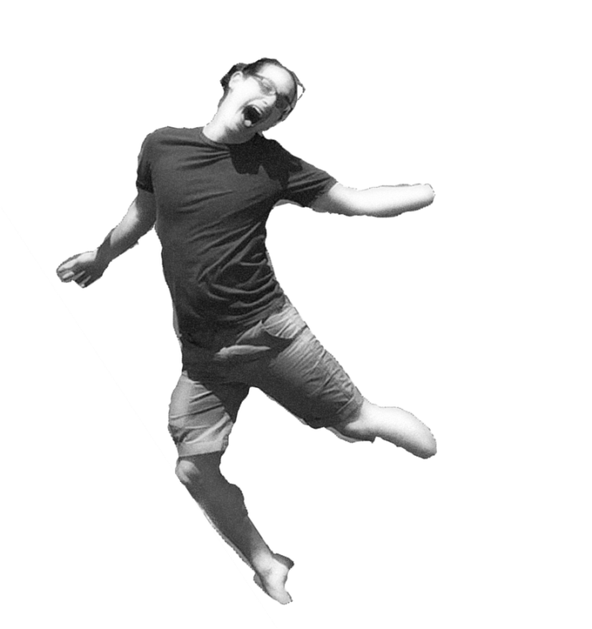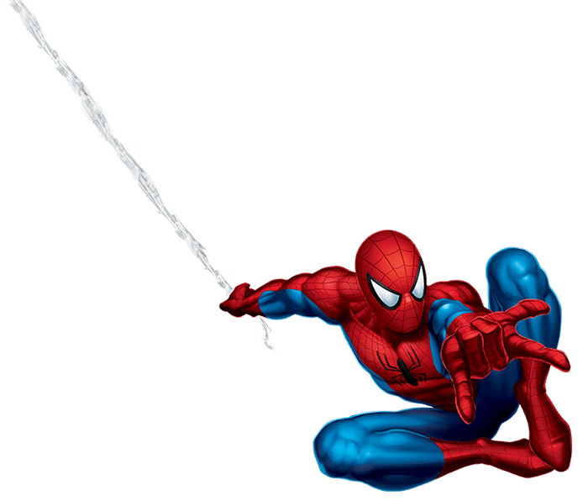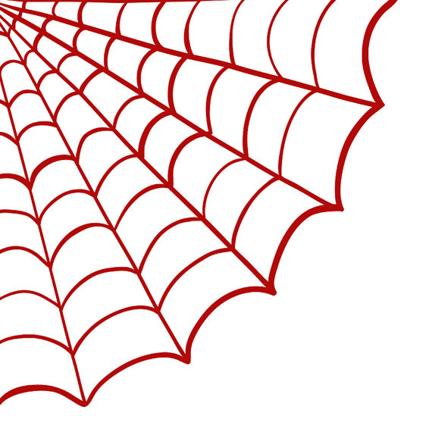

Look at me, I’m doing spider silks :3

Spider-Patrick SMASH!!

Lin Lab - 2018

Radioactivity Testing

**Month: Reading: Read by:**

December

September

October

November

August

July

June

May

March

April

February

January